# 1. What are escape characters, and how do you use them?

An escape character is a backslash \ followed by the character you want to insert. Using the escape character backlash \, we can insert whitespaces such as space, tab, formfeed, vertical tab, new line, carriage return, etc. In addition to whitespaces, we can also insert literal characters as is without invoking their special meaning.

For using the escape character you first mention the escape character in the string and subsequently adjacent to it you mention the character that needs to be escaped. Here is an example:

# 2. What do the escape characters n and t stand for?

# 3. What is the way to include backslash characters in a string?

Enter the backslash \ once as an escape character and then again enter the backslash \ which is then considered as a literal.

# 4. The string "Howl's Moving Castle" is a correct value. Why isn't the single quote character in the word Howl's not escaped a problem?

The single quote character in the word Howl’s not escaped is not a problem because single quotes are not used to enclose the string and instead the entire string is enclosed within double quotes. Thus the program would expect a double quote character to identify the end of the string. Encountering the single quote character thus has no impact.

# 5. How do you write a string of newlines if you don't want to use the n character?

You add newlines without using the ‘n’ character by enclosing the string in triple quotes ‘’’ or “””  
The triple quotes allows for multi-line strings. Thus a new line character in the code will be literally included in the string.

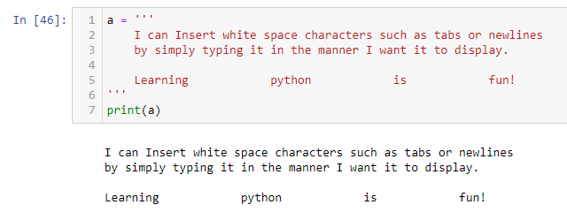

# 6. What are the values of the given expressions?

# 'Hello, world!'[1]

# 'Hello, world!'[0:5]

# 'Hello, world!'[:5]

# 'Hello, world!'[3:]

# 7. What are the values of the following expressions?

# 'Hello'.upper()

# 'Hello'.upper().isupper()

# 'Hello'.upper().lower()

# 8. What are the values of the following expressions?

# 'Remember, remember, the fifth of July.'.split()

# '-'.join('There can only one.'.split())

# 9. What are the methods for right-justifying, left-justifying, and centering a string?

# 10. What is the best way to remove whitespace characters from the start or end?

Use the strip method to remove leading and trailing whitespaces in a string.

